Task Description:

Launch jenkins and explore creating projects and users.

Step 1- launch an Ubuntu EC2 instance
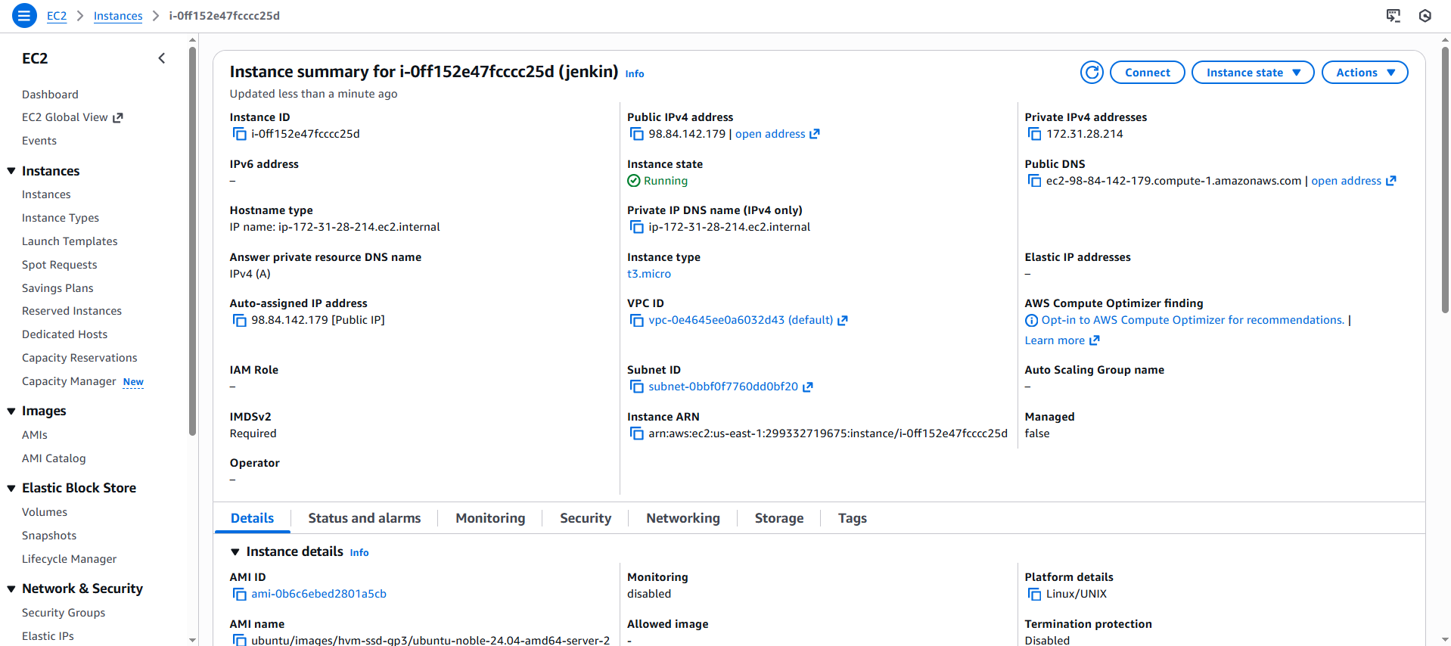

Step 2- Connect to the EC2 instance and install Jenkins, before installing Jenkin we need to Java as Java is the prerequisites
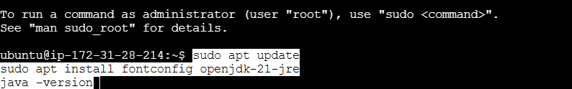
Once java is installed, proceed with installing Jenkins
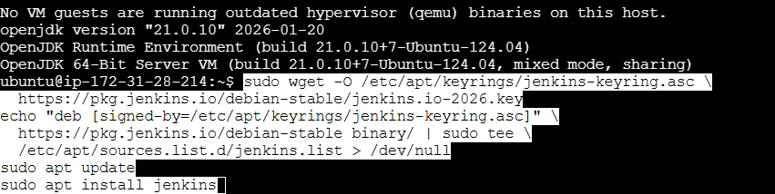

Step 3- Open Jenkin with instance public ip and port no
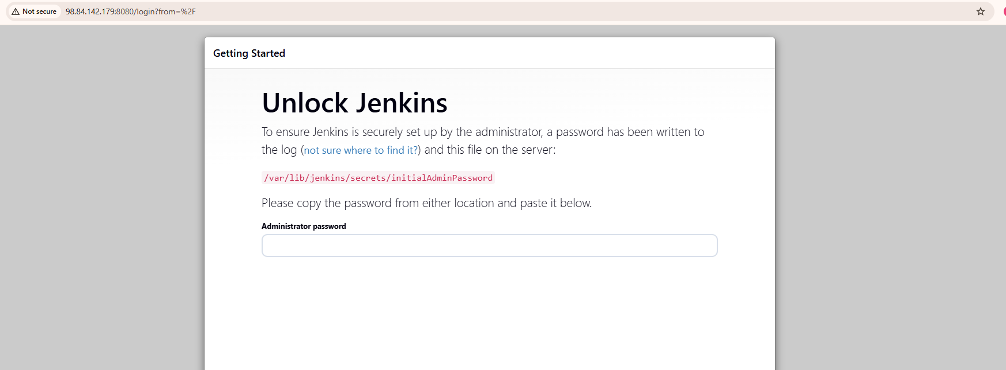
Take administrative password from /var/lib/jenkins/secrets/initialAdminPassword directory
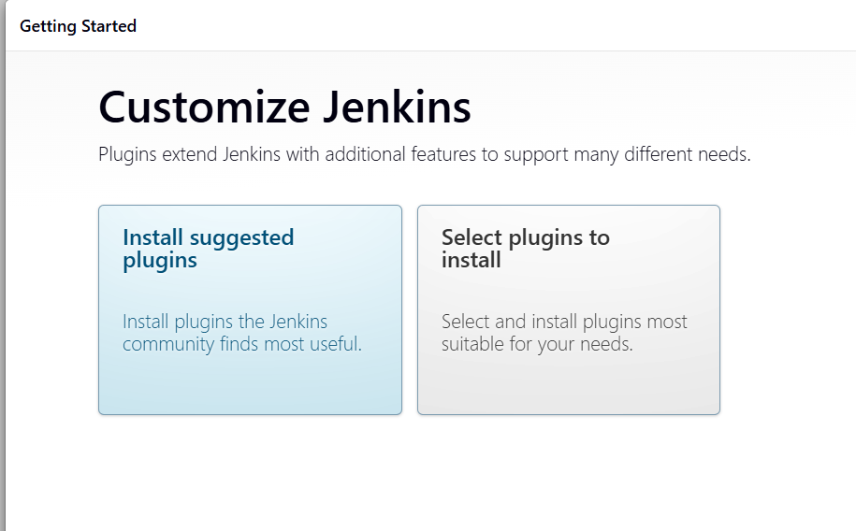

Step 4- Create first user on jenkin
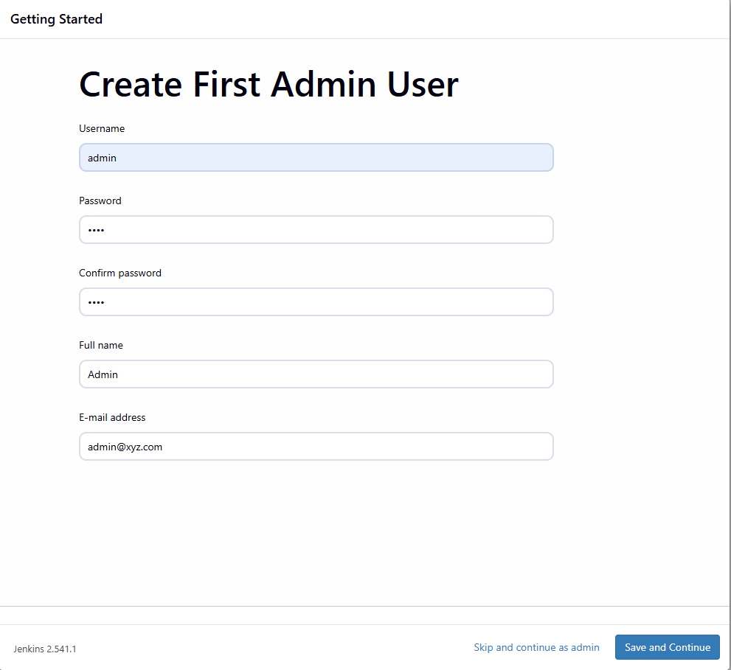

Step 5- Create project on jenkin, Click on new item
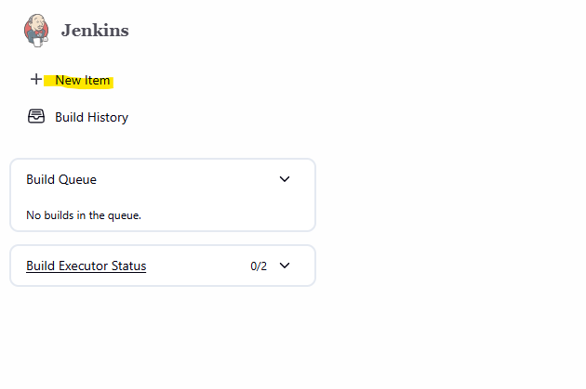
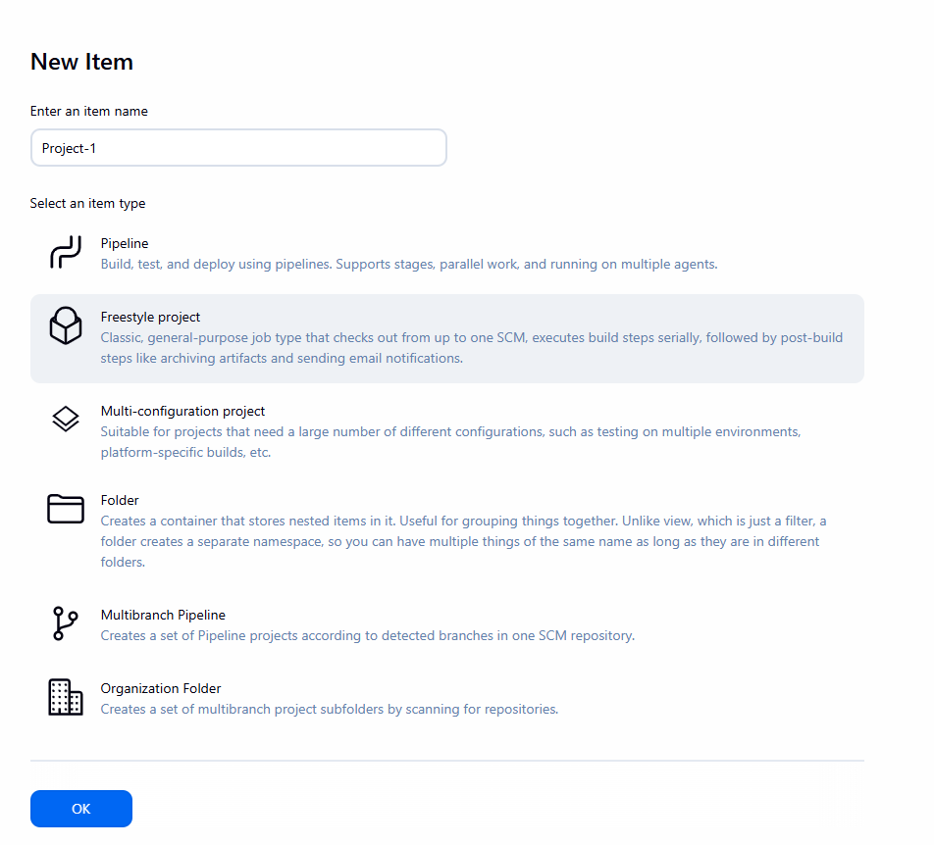
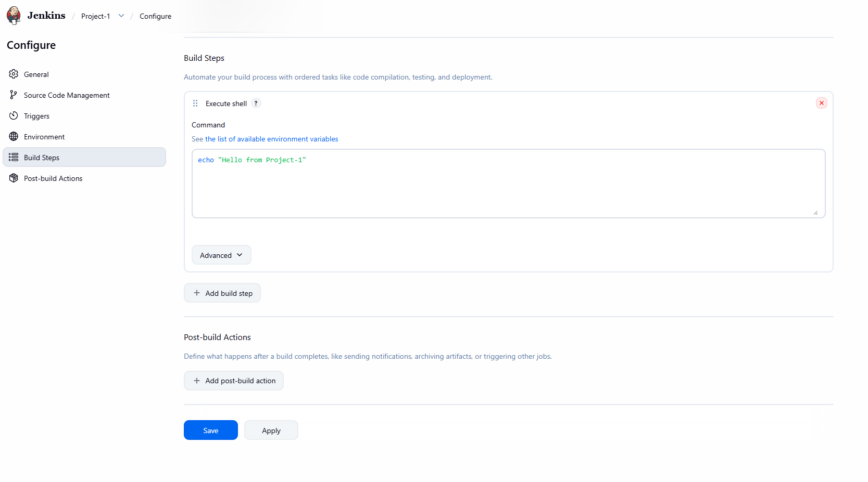
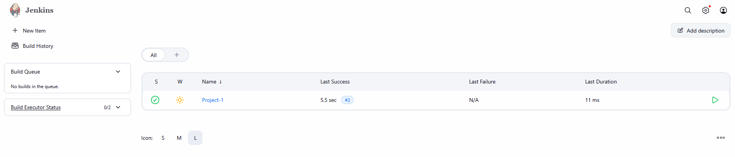

Step 6- Create users, Go to manage Jenkins and click on Users
